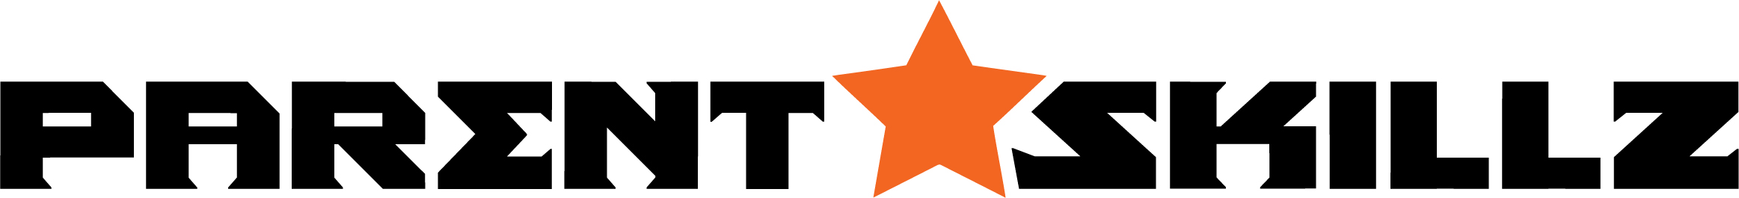
WEEK 4 CONNECTION

Hey Parents,

How did you do on the Parent SKILLZ of CONNECTION?

Give yourself a self-evaluation so you can continue to build Parent SKILLZ 1: CONNECTION, by either following this assignment privately, or posting your answers to our Parent’s Facebook page or a chance to win special prizes!

Scoring Scale:
1 = Not at all 2 = Rarely 3 = Sometimes 4 = Above average 5 = Exceptional

Question 1: On a scale of 1 to 5, how do you feel your level of CONNECTION was with your child before starting this course? _____

Question 2: On a scale of 1 to 5, how much did you participate in this month’s Parent SKILLZ? _____

Question 3: On a scale of 1 to 5, how do you rate your level of CONNECTION after participating in this course? _____

If you have any additional comments, please feel free to leave a few comments on how this month’s Parent SKILLZ content has on the overall growth of your relationship with your child.

Thank you for your participation in this month’s Parent SKILLZ! Be sure to tag a friend who would find this content resourceful!

#parentskillz #ps1connection

