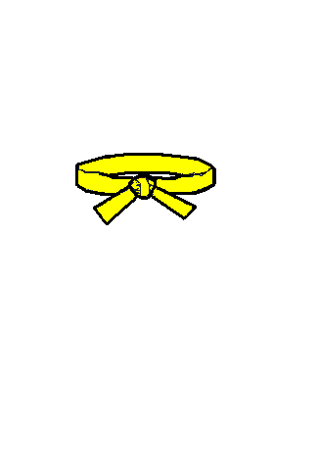
THEORY QUIZ FOR 8TH KUP / YELLOW BELT

Please circle the correct answer:

- The pattern for your grade is called:
Chon ji Dan gun Do San

- The meaning is:

Heaven and earth

Named after the Patriot Ahn chang Ho

Named after the legendary founder of Korea

- This pattern contains:
21 moves 24 moves 19 moves

- The colour green signifies:
Earth Danger The plants growth

- Link the following Korean words with the English:

 | Forearm Rising Block |  | Palmok daebi makgi
 | Twin Outer Forearm Block |  | Dung Joomuk Ap Naeryo Taerigi
 | Back Fist Front Downward Strike |  | Palmok Chookyo makgi
 | Forearm Guarding Block |  | Ap Cha Busigi
 | Outer Forearm Inward Block |  | Dollyo Chagi
 | Front Snap Kick |  | Anaero
 | Turning Kick | 14. | Example: Doo Jirugi
 | Ball of Foot |  | Bakaero
 | Knife Hand Guarding Block |  | Sonkal taerigi
 | Inward |  | Sang bakat palmok makgi
 | Outward |  | Sambo Matsoki
 | 3 Step Sparring |  | Sonkal Daebi Makgi
 | Knife Hand Strike |  | Kaunde Anaero bakat palmok makgi
 | Example: Double Punch |  | Ap Kumchi

